Child or young person’s views
What do you like about school?

What makes you happy?

What makes you sad?
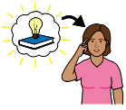
Who helps you to learn?
What helps you to learn?
Please provide details below of how these views were obtained or if this was completed by an advocate for the child.

Signed Date

