Recovery curriculum planning
Year group:  Upper Key Stage 2 | Key skills of activity:  - Children to share what they did at home and why they enjoyed at home  - Children to share what they are looking forward to doing at school  - Children to share what they are excited/nervous about  - Children to identify positive and difficult emotions about being at home and coming back to school  - Children to identify why we are experiencing these positive/negative emotions and identify how to share/work through these emotions.  Key vocabulary: Emotion; excited; nervous; positive; difficult; negative; worry; community
Theme:  Community | - Create a well-being journal  Have guiding questions:  What did you do during lockdown that you enjoyed?  What are you looking forward to now being able to do at school?  What are you excited about now that you are back in school?  What are you nervous about?  Draw a picture of yourself at home and label with how you feel.  Draw a picture of yourself at school and label how you feel.  Have you changed as a result of lockdown? How?  - Circle time  Share with volunteers information from well-being journals. Create a whole group display of emotions and discuss each one in turn. Explain that all emotions are valid and that we may all experience some, all or none of the same as others.  How can we deal with this emotion?  How can we support each other?  - Make Thank you cards  Create cards to show their appreciation to their parents/carers, who have helped them during lockdown. Members of the wider community could also be included in this. Perhaps, neighbours who were known to be working as key workers.  - Worry balloons  Create a display of balloons, with each balloon showing a particular worry or concern. Then show the balloons floating away with their worry.  - Share an activity  Children could share an activity that they enjoyed at home with the other children. E.g. perhaps they took up gardening. They could create a presentation to the others showing photos or drawings of the journey they made.  - Dealing with change  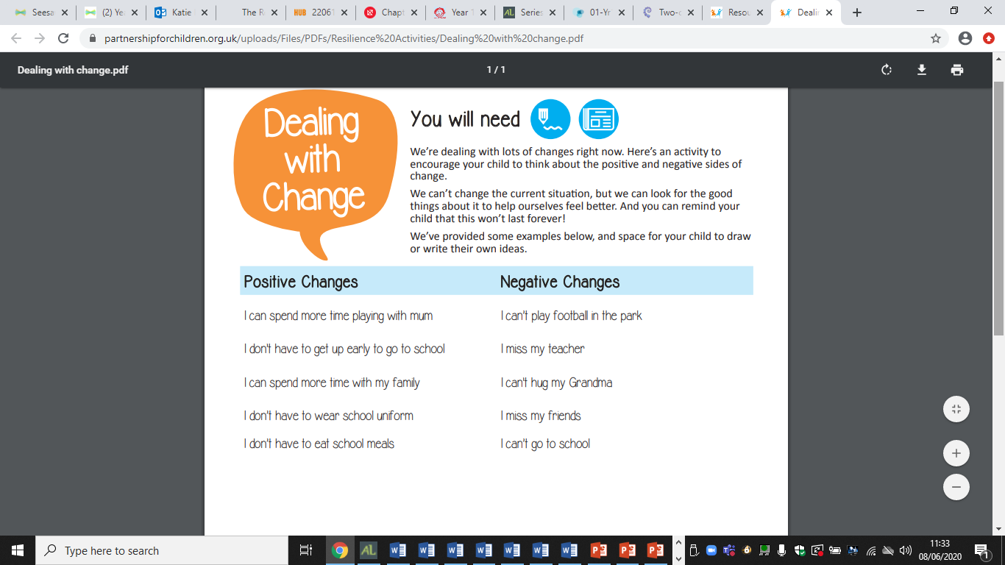  - Worry Jar  A Worry Jar is a place for your child to put their worries so they don’t have to think about them all the time. Find a jar or any container, and decorate it if you like. If you haven’t got a spare jar, you can write or draw on the picture on the following page.  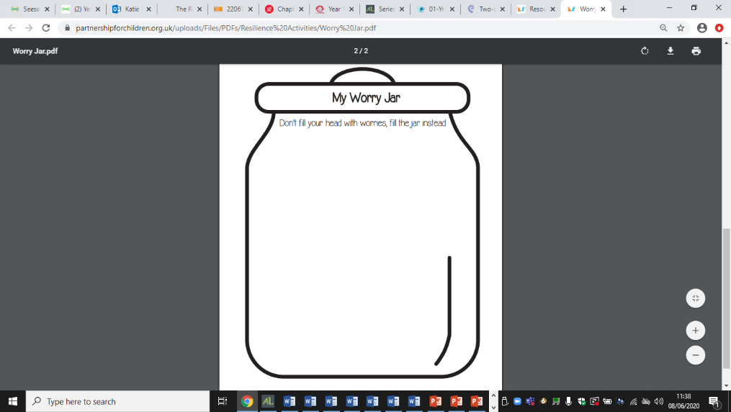  - Coping toolbox  Get children to create a coping toolbox. Explain that they should fill their coping toolbox with things which remind them of good times or will help them feel better. Examples: Photos, drawings, a gift which someone has given them, a sachet of hot chocolate, a bath bomb, a list of activities they can do to relax: Cuddle a teddy, watch their favourite DVD, take 10 deep breaths etc. Children could bring in a box or use an envelope that they can keep in their trays. Ask children to share what is in their toolbox and why.  - Different emotions  Tell the group: People can have more than one emotion at the same time. For example, you might feel happy when your lost dog comes home, but upset because he has a bruised paw. You could feel excited about finding the last piece of cake in the refrigerator, but unsure about whether you should eat it. The important thing is to try to be aware of all the emotions you’re feeling, and if they trouble you, talk about them with someone who will listen to you and can help. Get the children to draw themselves with thought bubbles explaining all the emotions they are feeling and why. Get pupils to share their thoughts and feelings.  - Missing  Fold a piece of paper into 4. In the top left box list all the things they missed about school when quarantine began. In the top right box list all the positive outcomes of being at home during quarantine. E.g. spending time with their family, learning new skills, becoming more independent etc.  In the bottom left hand box write all the things they will miss about being at home now they are back at school. In the bottom right had box list all the positive things about being back at school e.g. seeing their friends, having the teacher to help them, getting outside more etc.  Share what they have written as a class and discuss the different emotions these scenarios have caused them to feel.  Reassure that children that even though the things on left may make us feel sad, worried and scared, that there are always positive things that can come out of them which are those things on the right.  - Thought bubbles  Get the children to fold their paper in half and draw a picture of themselves on both halves of the paper.  Around the picture on the left draw thought bubbles with all the feelings and thoughts they had about when school closed.  Around the picture on the left draw thought bubbles with all the feelings and thoughts they have now about leaving home and being back at school.  Share some of these ideas as a class. How did we overcome these emotions when we were at home? How can we overcome them now?  Create a list as a class of all the positive outcomes from being in quarantine at home and what they hope will be the positive outcomes for being back in school. | Next steps/evaluation of activities:
Week: 2 of 5 | Guidance for teacher:  We must recognise that curriculum will have been based in the community for a long period of time. We need to listen to what has happened in this time, understand the needs of our community and engage them in the transitioning of learning back into school. | Additional support needed:  If you notice any pupils may need extra support with transition back to school, please make note here and speak to your Designated Safeguarding Lead/Pastoral Lead.

