# Ealing Book Festival Poetry and illustration competition

# Theme – My story, my future

### **Teacher resource pack**

**Contents**

Contents

About Ealing Book Festival 2

Ealing Book Festival 2025 resource pack 3

Competition rules 3

Poetry - My Story: task 1 5

Poetry - My story: Task 2**:** 6

Poetry – My story: Task 3 (Year group 3-6) 7

Poetry (Year groups 3 – 6) 8

Poetry: task 3 (Year groups 7-8) 9

Poetry (Year groups 7-8) 10

Poetry - My Future: Task 1 (Year groups 7 – 8) 11

Poetry - My future: Task 2: 12

Poetry – My future: Task 3 and 4 13

Writing your poem - My story, my future task 5, 6 14

Illustration - My Story task 1 15

Illustration – My story: Task 2 16

Illustration - My Future: Task 1 18

Illustration - My future: Task 2 19

Schools’ entry form 20

## About Ealing Book Festival

Ealing has a long and rich literary history. Many celebrated authors have had connections to the area and to this day Ealing remains home to a large community of writers.

At the same time, the London Borough of Ealing is the fourth most populous London borough, yet it hasn’t had a literary festival to call its own since 2009.

Ealing Book Festival grew out of a desire to establish an annual celebration of literature that enables authors - both from across the borough and elsewhere - to showcase and discuss their work, whilst allowing audiences of all ages to connect with fellow book lovers and explore Ealing’s vibrant literary scene.

The festival will take place at Pitzhanger Manor & Gallery and the University of West London between Thursday 24th April and Sunday 27th April 2025.

We hope to work with a diverse range of partners, community groups and schools to share stories and grow interest in books and literature across Ealing and West London.

The team behind Ealing Book Festival is highly experienced and well connected in the publishing industry. We are also grateful for the support of our authors, sponsors, volunteers and the wider Ealing community.

We are excited about writing the next chapter in Ealing's literary history.

## Ealing Book Festival 2025 resource pack

### Introduction and welcome

Thank you for your interest in the Ealing Book Festival’s Poetry and Illustration Competition.

This resource pack has been created by Gagandeep Owen-Chaggar for schools taking part in the competition. All entries should reflect this year’s theme which is ‘My story, my future’. We hope this pack will support many educators to inspire ideas for student entries. These resources can be adapted to suit the needs of the young people but have been aimed at Years 3 to 8 as we will be welcoming entries in the following categories:

* Year groups 3 and 4
* Year groups 5 and 6
* Year group 7
* Year group 8

The worksheets have been designed so that you can print them, and students can even fill them out independently. As there is a poetry and an illustration resource, the worksheets are split into two sections to reflect this. The accompanying PowerPoint combines all activities and is easily adapted if you did want to separate activities. However, you can also incorporate your own teaching style into every lesson and adapt the lessons to make the experience more interactive. For example, you can encourage students to discuss answers in pairs or read their draft poems aloud and comment on each other’s work.

## Competition rules

#### Eligibility

The competition is open to young people from Years 3 – 8

If a young person is not in the specified year groups on the date of entry, they cannot be considered

Each young person can enter only one poem and/or one illustration.

If a young person wants to submit a poem and an illustration, you should enter each one separately onto the entry form.

It must be their own original work.

They should write their name, school and their year group at the time of entry on the poem and on the back of the illustration.

#### Theme

All poems and illustrations should follow the theme **“My story, My Future”.**

#### Specifications

Poems should be A4 size landscape or portrait. Typed or handwritten

Illustrations can be A4 or A3 size landscape or portrait.

Illustration medium should be traditional such as paint, pencil, felt pen and ink.

Please contact the organisers at: [schoolsandcolleges@ealingbookfestival.com](mailto:schoolsandcolleges@ealingbookfestival.com) if you have any questions about competition entrants with SEND.

#### Submission process

Please use the school’s entry form to help us with the process of managing multiple entries from one school.

All entries should have the name, school and year group at the time of entry on the poem and on the back of the illustration.

Poems can be sent to: [schoolsandcolleges@ealingbookfestival.com](mailto:schoolsandcolleges@ealingbookfestival.com)

The original illustrations should be delivered to **Ealing Book Festival, Pitzhanger Manor and Gallery, Ealing Green, Ealing, W5 5EQ.**

**Please be aware we cannot return the illustrations so please keep a copy.**

The closing date for entries is **7 March 2025 at 5pm.**

We will notify schools of the prize winners by **Monday 24 March.**

It is anticipated that the prize giving will be held at **midday on Sunday 27 April**. This will be confirmed closer to the event.

#### Terms and conditions

The copyright of each poem and illustration remains with the author/artist. Authors of the winning poems and illustrations, by entering the competition, grant the organisers of the Ealing Book Festival permission to publish, broadcast and/or use their poem in promotional displays including, but not limited to, the Ealing Book Festival website and social media. The winning entries of the illustration competition will be printed on library cards.

The judges’ decisions are final. No correspondence will be entered into concerning the decisions of the judges.

## Poetry - Calendar flippingMy Story: task 1

**Task 1:** What is your story so far? Draw a timeline of the story of your life. Here are some ideas of memories or milestones that you can include:

* Your birthday
* Your earliest memory
* Family milestones e.g. the birth of a brother/sister, the arrival of a pet
* Family adventures e.g. trips to the park or holidays
* Your first day of school
* Your funniest memory
* Your scariest memory



## Poetry - My story: Task 2**:**

kes you who you are. Answer using words, phrases, sentences or doodles.

**Question1:** What is important to you?



**Question 6:** How would other people describe you?



**Question 5:** What makes you angry?



**Question 4:** What makes you sad?



**Question 3:** What makes you happy?



**Question 2:** What are your strengths? What makes you proud?



**Question 7:** Name your favourite….



* colour?
* game?
* subject at school?
* animal?
* person?
* hobby?
* food?

## Poetry – My story: Task 3 (Year group 3-6)

**Task 3:** Now you have written down the things that make up your story. Soon you will be turning this into lines of poetry. Let’s look at some examples of memories from a poem from last year’s competition.

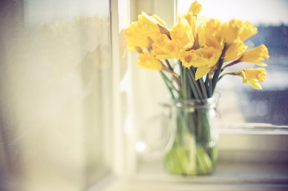**My Life**

I live in Southall,

Where we all thrive,

Me and my family,

We live in our own land.

A sea of colour wherever you go,

A touch, a warm breath, brushes my face

Long, yellow, tubular trumpets

Stunning

Ramadan is just what I do sometimes

We fast like-wise

Late Eid comes by

Presents, chocolates, say no more!

Fun, fun, fun!

Spring daffodils dancing in the breeze

Children chitter-chatter in the playground.

## Poetry (Year groups 3 – 6)

**Question 1:** Give an example of how the poet has described the senses to show what his life in Southall feels like?

**Question 2:** Give an example of how the poet has used colour to create imagery.

**Question 3:** Give an example of how the poet has used repetition.

**Question 4:** Give an example of how the poet has used alliteration?

**Question 5:** Give an example of how the poet has used punctuation to create rhythm.

**Question 6:** What is your favourite line in the poem and why?

**Question 7:** What is important to the poet? How do you know?

## Poetry: task 3 (Year groups 7-8)

**Task 3:** Now you have written down the things that make up your story. Soon you will be turning this into lines of poetry. Let’s look at some examples of memories in a poem from last year’s competition.

**Southall from my perspective**

Crowds bustling through streets,

While others are either hanging out with friends,

Or just settling down at Chaiwala,

Sipping a ‘cuppa’ of karak chai.

You could also be out for savoury snacks,

Like fresh, sweet Jalebi,

Even your stomach roars *only* by the sounds of it!

But if you’re craving something else,

You could always try some Gulab Jamun,

Don’t worry- it’s all available in mithai stalls.

I’m aware I’ve been speaking for quite some time,

Only about chai and mithai,

I’m aware I sound boring,

But all hope is not lost.

Even when you’re not out and about,

Not having a ‘cuppa’ of chai or buying some ‘chevdo’,

You can always have fun at home,

Although your mum is dealing with your sibling,

Or your dad has gone to his 9 to 5 job.

This is Southall- its main quality is being **unique**!

## Poetry (Year groups 7-8)

**Question 1:** Give an example of how the poet has described the senses to show what his life in Southall feels like?

**Question 2:** Give an example of how the poet has used adjectives to create imagery?

**Question 3:** Give an example of how the poet has used punctuation to create rhythm in the poem.

**Question 4:** What is your favourite line in the poem and why?

**Question 5:** What is important to the narrator? How do you know?

## Poetry - My Future: Task 1 (Year groups 7 – 8)

**Task 1:** When you think about your future, what do you imagine? Write out your ideas here. You could think about what you imagine for your own life and the wider world.

Here are some ideas:

* What does your future look like?
* Where do you live?
* Who do you live with? E.g. family, friends, pets
* Do you have a job?
* How is the wider world different?
* What are you excited about for your future?
* What makes you nervous about your future?

## Poetry - My future: Task 2:

The theme ‘My future’ can include hopes, dreams and aspirations for yourself and the world. Look at these images.

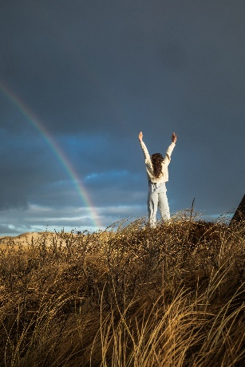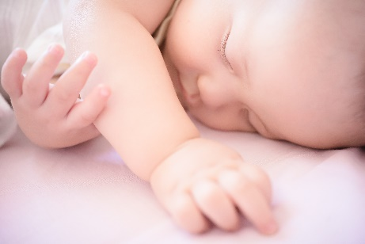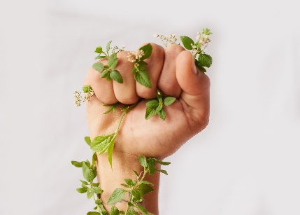 

Which one stands out to you or inspires you? Why?

What images would you pick to represent hope, dreams and future?

## Poetry – My future: Task 3 and 4

**Task 3:** What would you change about the world to make a better future for yourself and others?

**Task 4:** Let’s read a poem from last year’s competition to see how one person has chosen to write about the future. You can read the poem aloud as a class or in pairs.

**I Wish**

Sometimes I wish I lived on Mars,

Or somewhere among the stars.

Up there all alone,

May seem bad to some people,

But I would love to call that place home.

All you see in Southall are crowded streets,

Something about Southall does not connect with me.

So much all at once,

I just want to be free.

I wish there were a few days of quiet,

Where we can have some space.

I do love all the shops though,

And the friendly people you may meet on your way.

**Question 1:** What does the narrator wish for?

**Question 2:** Why do you think the narrator wishes for these things?

**Question 3:** What are your biggest wishes and dreams for your future? Can you think about why you have these hopes and dreams?

## Writing your poem - My story, my future task 5, 6

**Task 5:** Now you have written down ideas about your story and your future. You can use all this inspiration to write your own poem to enter our competition!

**Poetry editing and drafting**

**Task 6:** Now that you have written a first draft of your story, here are some ideas to edit and improve your ideas further.

1. Read your poem carefully. Check your spelling and punctuation is correct. Does your poem make sense? Have you used lines and/or stanzas to organise your work? Is your handwriting neat and clear? Can you think of any improvements you could make. Here are some ideas. Think about: vocabulary, rhythm, lines, punctuation, imagery, adjectives, verbs, senses.
2. Read your poem aloud to your class or adults at home. Try to change the emotion, volume and pace of your voice to show meaning. Does your audience have any suggestions?

## A person with a question mark Description automatically generatedIllustration - My Story task 1

This year’s theme is **My story, my future.** Let’s start by thinking about your story.

**Task 1:** Who are you? Draw an illustration of how you see yourself.

## Illustration – My story: Task 2

What is your story so far? Draw a timeline of the story of your life. Here are some ideas of memories or milestones that you can include:

* Your birthday
* Your earliest memory
* Family milestones e.g. the birth of a brother/sister, the arrival of a pet
* Family adventures e.g. trips to the park or holidays
* Your first day of school
* Your funniest memory
* Your scariest memory



Illustration : Task 2

kes you who you are. Answer using words, phrases, sentences or doodles.

**Question1:** What is important to you?



**Question 6:** How would other people describe you?



**Question 5:** What makes you angry?



**Question 4:** What makes you sad?



**Question 3:** What makes you happy?



**Question 2:** What are your strengths? What makes you proud?



**Question 7:** Name your favourite….



* colour?
* game?
* subject at school?
* animal?
* person?
* hobby?
* food?

## Illustration - My Future: Task 1

When you think about your future, what do you imagine? Draw out your ideas here. You could think about what you imagine for your own life and the wider world.

Here are some ideas:

* What does your future look like?
* Where do you live?
* Who do you live with? E.g. family, friends, pets
* Do you have a job?
* How is the wider world different?
* What are you excited about for your future?
* What makes you nervous about your future?

## Illustration - My future: Task 2

**Task 2:** The theme ‘My future’ can include hopes, dreams and aspirations for yourself and the world. Look at these images.

 

|  |
| --- |
| Which one stands out to you or inspires you? Why?  What images would you pick to represent hope, dreams and future? |
| **Task 3:** What would you change about the world to make a better future for yourself and others? |
| **Task 4:** Your turn! Draw your illustration for the competition |

.

###### Festival FAQs | Ealing Book Festival**Ealing Book Festival Young People’s Poetry and Illustration Competition 2025**

## Schools’ entry form

|  |  |
| --- | --- |
| **School** |  |
| **Address** |  |
| **Contact teacher full name** |  |
| **Contact teacher email** |  |

|  |  |  |  |  |
| --- | --- | --- | --- | --- |
|  | **Pupil’s full name** | **Year group** | **Is the entry a poem or illustration** | **Title of poem / illustration** |
| **1** |  |  |  |  |
| **2** |  |  |  |  |
| **3** |  |  |  |  |
| **4** |  |  |  |  |
| **5** |  |  |  |  |
| **6** |  |  |  |  |
| **7** |  |  |  |  |
| **8** |  |  |  |  |
| **9** |  |  |  |  |
| **10** |  |  |  |  |
| **11** |  |  |  |  |
| **12** |  |  |  |  |
| **13** |  |  |  |  |
| **14** |  |  |  |  |
| **15** |  |  |  |  |
| **16** |  |  |  |  |
| **17** |  |  |  |  |
| **18** |  |  |  |  |
| **19** |  |  |  |  |
| **20** |  |  |  |  |
| **21** |  |  |  |  |
| **22** |  |  |  |  |
| **23** |  |  |  |  |
| **24** |  |  |  |  |
| **25** |  |  |  |  |
| **26** |  |  |  |  |
| **27** |  |  |  |  |
| **28** |  |  |  |  |
| **29** |  |  |  |  |
| **30** |  |  |  |  |

Enquiries: [schoolsandcolleges@ealingbookfestival.com](mailto:schoolsandcolleges@ealingbookfestival.com)