**Springhallow Autism Conference 2024**

***Autism and its Complexities***

Friday 9th February

Arrival from 8.45am for a 9.15 start – 3.30pm

£55 per person includes lunch





**Delegate details** *(complete one form per delegate/place required)*

**Please send completed booking forms to Nichola Curran** [**outreach@springhallow.ealing.sch.uk**](mailto:outreach@springhallow.ealing.sch.uk)

|  |  |
| --- | --- |
| Name |  |
| Role |  |
| Contact email |  |
| Contact number |  |
| School/Organisation |  |

|  |  |
| --- | --- |
| Dietary requirements |  |
| Access requirements |  |

|  |
| --- |
| **Itinerary**  8:45 Arrivals, refreshments and network opportunities  9:15 Welcome, housekeeping, outreach service, conferences and itinerary Student Voice  9:30 Complexities from a Personal Perspective - Dean Beadle (Part 1)  10:30 Break refreshments available  10:45 Dean Beadle (Part 2) Including questions  11:45 Autism and Co-Occurring Conditions and Complexities - Dr Paul Williams (Clinical Psychologist)  12:10 Parent Speaker – Autism and Race - Annette Ridge  12:30 Buffet lunch and network opportunities  1:15 Attendance CME/EBSA/EHE Aoife Jenkinson (Educational Psychologist)  1:35 Parent Speaker - Perspectives of Families - Natasha Parslow  1:50 Preparation towards Independence-Safety in the Community - Tamara Whittick-Rice Essex CC Travel Trainer  2:10 Parent Speaker - Autism and Gender Identity - Karen Markham  2:30 Panel  3:00 Closing remarks  (Timings are approximate) |

**Invoice details:** (who we should send our invoice to)

|  |  |
| --- | --- |
| Name |  |
| Contact email |  |
| Invoice address |  |

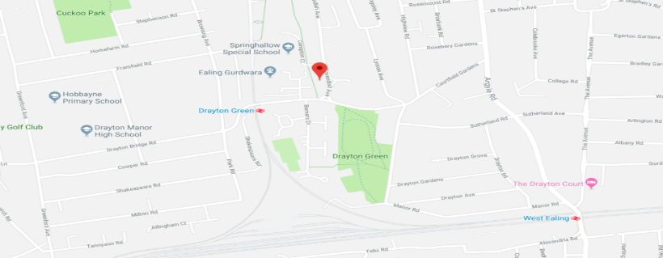**Springhallow School**

**Compton Close**

**Ealing**

**W13 0JG T: 020 8998 2700 option 2, then option 4**

**Parking will be available within the school site.**